**MINOR PROJECT REPORT**

ON

***“MOBILE CLONING AND ITS DETECTION”***

*Submitted In Partial Fulfilment Of The Requirements*

*For The Award Of The Degree Of*

**Bachelor Of Technology**

**In**

**Computer Science And Engineering**

**Guide:** **Submitted By:**

Mr. Arun Kumar Akash Sinha (03796502710)

Assistant Professor Alok (04796502710)

Deptt Of Computer Science Ajay Dagar (05096502710)

Harshit Trivedi (06496502710)



**HMR Institute of Technology & Management**

**Hamidpur, Delhi 110036**

**Affiliated to**

**GURU GOBIND SINGH INDRAPRASTHA UNIVERSITY**

**Sector - 16C Dwarka, Delhi - 110075, India**

**2010-14**

**CERTIFICATE OF ORIGINALITY**

This is to certify that the Minor Project Report entitled **“Mobile Cloning And Its Detection”** developed by AKASH SINHA (03796502710), ALOK (04796502710), AJAY DAGAR (05096502710) and HARSHIT TRIVEDI (06496502710) is an authentic work carried out by them under my guidance and supervision. The matter embodied in this project has not been submitted earlier for the award of any degree or diploma to the best of my knowledge and belief.

**DATE**: **SIGNATURE OF GUIDE:**

Mr. Arun Kumar

Assistant Professor

Deptt Of Computer Science

**DECLARATION**

We hereby declare that the Minor Project entitled **“Mobile Cloning And Its Detection”** submitted to HMR Institute Of Technology And Management in partial fulfilment of requirement for the award of degree of Bachelor Of Technology in Computer Science And Engineering is a record of bonafide project work carried out under the guidance of Mr. Arun Kumar.

We further declare that this project has not been submitted for the award of any other degree in any other institutes or universities.

**DATE:**

|  |  |  |  |
| --- | --- | --- | --- |
| ______________ | ______________ | _______________ | _______________ |
| Akash Sinha | Alok | Ajay Dagar | Harshit Trivedi |
| (03796502710) | (04796502710) | (05096502710) | (06496502710) |

**ACKNOWLEDGEMENT**

We take this opportunity to express our profound gratitude and deep regards to our guide Mr. Arun Kumar for his exemplary guidance, monitoring and constant encouragement throughout the course of this project.

We also take this opportunity to express a deep sense of gratitude to the faculty of Computer Science Department for their cordial support and guidance, which helped us in completing this task through various stages.

Lastly, we thank the almighty, our parents and friends for their constant love, support and encouragement without which this project would not be possible.

Sincerely,

|  |  |  |  |
| --- | --- | --- | --- |
| ______________ | ______________ | _______________ | _______________ |
| Akash Sinha | Alok | Ajay Dagar | Harshit Trivedi |
| (03796502710) | (04796502710) | (05096502710) | (06496502710) |

**ABSTRACT**

Cloning is the act of making one cellular phone "act the same" as another. This is accomplished by copying the identity and phone number of one phone and inserting it into another. The phones do NOT have to be the same model or even the same brand.

The second phone is now for all purposes the same as the first. It will ring if one when the original phones rings. It will cause any charges incurred, to be billed on the original phone's monthly billing statement.

The Cellular Telecommunications Industry Association (CTIA) estimates that financial losses in due to cloning fraud are between $600 million and $900 million in the United States. In India, the very first cases of GSM SIM Mobile Cloning have been reported as early as the year 2005. In one such case, South-West Delhi police had arrested seven people on charges of duping mobile service provider Hutch (now Vodafone) of over Rs. 9 lakhs by arranging international calls through cloned cards from Saudi Arabia. The gang had in fact cloned the SIM cards and sent them to Saudi Arabia to be used to make calls to India without detection.

Due to the ethical dilemma surrounding the practical implementation of this topic, the research and study may be restricted to only theoretical approach in some areas. So we have used the technique of duplicate detection to virtually detect cloning of two numbers. We have used MySQL as a Server which has a database that stores all the information of a client registered to it. When we try to clone a phone, a thread will randomly generate which show two different location of phone with same mobile number and cloning is detected.

**PROBLEM STATEMENT**

In this project we have used two detection techniques, i.e. **Duplicate Detection** and **Velocity Trap** to detect the presence of Mobile Cloning. The aim of this project is to detect virtually that the cloned phone exists along side with the original number.

In recent past most of the phones have been cloned and many criminal use cloned cellular telephones for illegal activities , because their calls are not billed to them , and are therefore much more difficult to trace . In this project we have shown virtually that if two **ESN** (Electronic Serial Number) are active at the same time from two different locations then our server detects it because it is not possible for a single number to be active at two random places at the same time . Hence the cloned phoned is detected and its service is blocked and this can be used to keep trace of the unauthorised user.

**TABLE OF CONTENTS**

|  |  |  |
| --- | --- | --- |
| **S.No.** | **Content** | **Page No.** |
|  | | |
| i | **CERTIFICATE OF ORIGINALITY** | 2 |
| ii | **DECLARATION** | 3 |
| iii | **ACKNOWLEDGEMENT** | 4 |
| iv | **ABSTRACT** | 5 |
| v | **PROBLEM STATEMENT** | 6 |
| 1 | **INTRODUCTION** | 11 |
| 1.1 | Morality/Ethics | 11 |
| 1.2 | Process | 11 |
| 1.3 | Tracking & prevention | 12 |
| 1.4 | Practical approach | 12 |
| 1.5 | Scope | 12 |
| 2 | **OBJECTIVES OF THE PROJECT** | 14 |
| 3 | **LITERATURE REVIEW** | 15 |
| 2.1 | Introduction to Java | 20 |
| 2.2 | Java Platform | 21 |
| 2.3 | Java Virtual Machines | 23 |
| 2.4 | Class Libraries | 24 |
| 2.5 | Languages | 24 |
| 2.6 | Java Development Kit | 25 |
| 2.7 | What Can Java Technology Do? | 26 |
| 2.8 | Features Of Java Platform | 27 |
| 4 | **SELECTED SOFTWARE** | 28 |
| 3.1 | NetBeans IDE | 28 |
| 3.2 | MySQL | 30 |
| 3.3 | SQLyog | 31 |
| 5 | **SYSTEM DESIGN** | 36 |
| 4.1 | Hardware Requirements | 36 |
| 4.2 | Software Requirements | 36 |
| 6 | **UML DIAGRAMS** | 38 |
| 5.1 | Use - Case Diagram | 38 |
| 5.2 | Workflow of Various model | 43 |
| 5.3 | Sequence Diagram | 45 |
| 5.4 | E-R Diagram | 47 |
| 5.5 | Data Flow Diagram | 48 |
| 7 | **TESTING** | 50 |
| 8 | **CONCLUSION** | 51 |
| 9 | **APPENDIX** | 52 |
| 10 | **BIBLIOGRAPHY** | 58 |
|  |  |  |
|  |  |  |
|  |  |  |

**LIST OF ILLUSTRATIONS**

|  |  |  |
| --- | --- | --- |
| **Fig No.** | **Illustrations** | **Page No.** |
|  | | |
| 1 | Program Running On Java Platform | 21 |
| 2 | Java 2 SDK | 26 |
| 3 | Working Of Java Program | 27 |
| 4 | Use Case for Detection of Mobile Cloning | 38 |
| 5 | Workflow for User Registration | 43 |
| 6 | Workflow for Clone Phone | 44 |
| 7 | Sequence Diagram | 45 |
| 8 | Entity Relationship Diagram | 47 |
| 9 | Level - 0 DFD | 48 |
| 10 | Level - 1 DFD | 49 |
| 11 | Shows how to run the project. | 52 |
| 12 | Shows the pop up window | 53 |
| 13 | Shows the Registration window for registration | 54 |
| 14 | Shows the database of registered numbers. | 55 |
| 15 | Shows the details of the fair registered user | 56 |
| 16 | Shows the cloning of phone. | 57 |
|  |  |  |
|  |  |  |
|  |  |  |

**LIST OF TABLES**

|  |  |  |
| --- | --- | --- |
| **TABLE N0.** | **TABLE NAME** | **PAGE NO** |
|  | | |
| 1 | Use Case Description | 39 |
| 2 | Test Cases | 50 |
|  |  |  |
|  |  |  |

**1. INTRODUCTION**

There has been much written about the legality of cloning one cellular phone to another. There is also much confusion as to whether or not a person who "clones" a phone is actually breaking the law.

And just what is cloning? Cloning is the act of making one cellular phone "act the same" as another. This is accomplished by copying the identity and phone number of one phone and inserting it into another. The phones do NOT have to be the same model or even the same brand.

The second phone is now for all purposes the same as the first. It will ring if one when the original phones rings. It will cause any charges incurred, to be billed on the original phone's monthly billing statement.

**1.1 MORALITY/ETHICS**

Herein lies the problem. By stealing somebody else's mobile number (MIN) and Electronic Serial Number (ESN), a person can "clone" a cellular phone and then make calls which are charged unlawfully to another. This is clearly illegal and is essentially a ‘fraud’.

What however, if the person who owns the original phone also owns and uses the clone? Then there is NO theft of service; no crime. No fraud. The second phone becomes an 'extension' so to speak. Why would anybody want an extension? Users generally use a cloned cell phone to expand their communications capabilities. Interesting enough, some cellular companies are now starting to offer cloning as part of their service package(s).

**1.2 PROCESS**

To clone one phone to another requires the extraction of the ESN (Electronic Serial Number) from the master phone and insertion into the phone to be cloned. This is typically accomplished in older phones by opening up the master phone and removing the PROM or EPROM holding the ESN, and other data, and copying it. In newer phones, the data is removed via a serial cable connection to a computer.

A file is made from the original extracted data changing data as necessary. Once a computer file has been made, a second blank chip, the same type as in the phone to be cloned, is then reprogrammed with the ESN and other data from the master. The entire procedure can be completed within 1 hour, much less after the first phone is done. With later models phones, the data is sent back to the cloned phone via the same serial cable.

**1.3 TRACKING & PREVENTION**

There are some ways to detect and prevent this type mobile fraud. Also, there are various practices that a mobile user can exercise to prevent his/her mobile from getting hacked or cloned.

**1.4 PRACTICAL APPROACH**

Due to the ethical dilemma surrounding the practical implementation of this topic, the research and study may be restricted to only theoretical approach in some areas. But, a full effort will be made to practically demonstrate the various aspects of Mobile SIM Cloning, its detection, tracking and prevention.

**1.5 SCOPE**

Mobile cloning is working as a speed breaker in the growth of m-commerce. Nowadays mobile becomes an essential part of our daily routine. Positive use of Mobile Cloning is creating a cloned SIM which has the same identity and contacts as in your original phone. But nowadays total meaning of Mobile Cloning has changed. Today, it is done for the purpose of making fraudulent telephone calls. The bills for the calls go to the legitimate subscriber. The cloner is also able to make effectively anonymous calls, which attracts another group of interested users. It is also mandatory to keep in mind that a technique which is safe today can be the most unsecured technique in the future. Finally, maintaining security is mandatory in critical applications like m-commerce. This part will focus on basics of Mobile cloning,

1. Different aspects of Mobile Cloning.

2. Methods to know if a cell phone has been cloned.

3. How to prevent Mobile Cloning.

4. Mobile Security and future scope of Mobile Cloning.

### 2. OBJECTIVES OF THE PROJECT

### The main objectives of our project are -

* To give an overview of Mobile Communication and Mobile Cloning.
* To show how Mobile Cloning is done.
* To virtually detect Mobile Cloning through a Client-Server system.

**3. LITERATURE REVIEW**

Mobile communication has been readily available for several years, and is major business today. It provides a valuable service to its users who are willing to pay a considerable premium over a fixed line phone, to be able to walk and talk freely. Because of its usefulness and the money involved in the business, it is subject to fraud. Unfortunately, the advance of security standards has not kept pace with the dissemination of mobile communication.

Some of the features of mobile communication make it an alluring target for criminals. It is a relatively new invention, so not all people are quite familiar with its possibilities, in good or in bad. Its newness also means intense competition among mobile phone service providers as they are attracting customers.

**WHAT IS CELL PHONE CLONING?**

Cloning is the act of making one cellular phone "act the same" as another. This is accomplished by copying the identity and phone number of one phone and inserting it into another. The phones do NOT have to be the same model or even the same brand.

The second phone is now for all purposes the same as the first. It will ring if one when the original phones rings. It will cause any charges incurred, to be billed on the original phone's monthly billing statement.

**HOW IS CELL CLONING DONE?**

Cloning involved modifying or replacing the EPROM in the phone with a new chip which would allow you to configure an ESN (Electronic Serial Number) via software. You would also have to change the MIN (Mobile Identification Number). When you had successfully changed the ESN/MIN pair, your phone was an effective clone of the other phone. Cloning required access to ESN and MIN pairs. ESN/MIN pairs were discovered in several ways:

* Sniffing the cellular
* Trashing cellular companies or cellular resellers
* Hacking cellular companies or cellular resellers

Cloning has been successfully demonstrated under GSM, but the process is not easy and it currently remains in the realm of serious hobbyists and researchers.

**Why would I want to make a clone of my card?**

There are many different opinions on that:

1) You can have a backup of your card in case you lose your phone

2) You can use the same Phonebook on all your numbers on the SIM in your cloned card.

3) You can have different Network providers on the same clone (but only one will always be active).

4) This can come in handy when you are traveling and would rather use a cheap phone instead of your more expensive high-end version, in case it gets lost or stolen.

**ARE OUR CELL PHONES SECURED?**

Too many users treat their mobile phones as gadgets rather than as business assets covered by corporate security policy. Did you realize there's a lucrative black market in stolen and "cloned" SIM cards? This is possible because SIMs are not network specific and, though tamper-proof, their security is flawed. In fact, a SIM can be cloned many times and the resulting cards used in numerous phones, each feeding illegally off the same bill.

But there are locking mechanisms on the cellular phones that require a PIN to access the phone. This would dissuade some attackers, foil others, but might not work against a well financed and equipped attacker. An 8-digit PIN requires approximately 50,000,000 guesses, but there may be ways for sophisticated attackers to bypass it.

With the shift to GSM digital - which now covers almost the entire UK mobile sector - the phone companies assure us that the bad old days are over. Mobile phones, they say, are secure and privacy friendly.

This is not entirely true. While the amateur scanner menace has been largely exterminated, there is now more potential than ever before for privacy invasion.

The alleged security of GSM relies on the myth that encryption - the mathematical scrambling of our conversations - makes it impossible for anyone to intercept and understand our words. And while this claim looks good on paper, it does not stand up to scrutiny.

The reality is that the encryption has deliberately been made insecure. Many encrypted calls can therefore be intercepted and decrypted with a laptop computer.

**HOW BIG OF A PROBLEM IS CLONING FRAUD?**

The Cellular Telecommunications Industry Association (CTIA) estimates that financial losses in due to cloning fraud are between $600 million and $900 million in the United States.

In India, the very first cases of GSM SIM Mobile Cloning have been reported as early as the year 2005. In one such case, South-West Delhi police had arrested seven people on charges of duping mobile service provider Hutch (now Vodafone) of over Rs. 9 lakhs by arranging international calls through cloned cards from Saudi Arabia. The gang had in fact cloned the SIM cards and sent them to Saudi Arabia to be used to make calls to India without detection.

After various such incidents, BSNL had issued a warning to users to not respond to calls from numbers starting with +92, #90 or #09, saying if they do they may fall prey to a bout of SIM card cloning.

According to a report in TOI, BSNL has issued alerts to subscribers — particularly about these series mentioned above — saying that calling the number back after a missed call may make a user susceptible to SIM card cloning.

There have been instances of subscribers receiving missed calls from numbers starting from +375 and this been on a rise in the recent past. These instances are alarming because if one tries to call back, then they’re charged a whopping $15 – $30 for that call. +375 is an international code, more specifically belonging to Belarus.

In another case last year, some subscribers of Reliance had to suffer because their phone was cloned.

Mobile Cloning Is in initial stages in India so preventive steps should be taken by the network provider and the Government.

**HOW TO KNOW THAT THE CELL HAS BEEN CLONED?**

• Frequent wrong number phone calls to your phone, or hang-ups.

• Difficulty in placing outgoing calls.

• Difficulty in retrieving voice mail messages.

• Incoming calls constantly receiving busy signals or wrong numbers. Unusual calls appearing on your phone bills.

**CAN CALLS ON CLONED PHONE BE TRACKED?**

Yes. A SIM can be cloned again and again and they can be used at different places. Messages and calls can track sent by cloned phones. However, if the accused manages to also clone the IMEI number of the handset, for which software’s are available, there is no way the cell can be traced.

**PREVENTION OF SIM CLONING**

An ESN/MIN pair uniquely identifies a mobile unit within a wireless carrier's network. The MIN often can be dialed from other wireless or wire line networks. The number differs from the electronic serial number (ESN), which is the unit number assigned by a phone manufacturer. MINs and ESNs can be checked electronically to help prevent fraud.

* Mobiles should never be trusted for communicating/storing confidential information.
* Always set a Pin that's required before the phone can be used.
* Check that all mobile devices are covered by a corporate security policy.

Ensure one person is responsible for keeping tabs on who has what equipment and that they update the central register. How do service providers handle reports of cloned phones?

Legitimate subscribers who have their phones cloned will receive bills with charges for calls they didn't make. Sometimes these charges amount to several thousands of dollars in addition to the legitimate charges.

Typically, the service provider will assume the cost of those additional fraudulent calls. However, to keep the cloned phone from continuing to receive service, the service provider will terminate the legitimate phone subscription. The subscriber is then required to activate a new subscription with a different phone number requiring reprogramming of the phone, along with the additional headaches that go along with phone number changes.

**3.1 INTRODUCTION TO JAVA**

Java is a set of several computer software products and specification from Sun Microsystems (which has since merged with Oracle Corporation), that together provide a system for developing application software and deploying it in a cross-platform computing environment. Java is used in wide variety of computing platforms from embedded devices and mobile phones on the low end, to enterprise servers and supercomputers on the high end. While less common on desktop computers. Java applets are sometimes used to provide improved and secure functions while browsing the World Wide Web.

Writing in Java programming language is a primary way to produce code that will be deployed as Java bytecode. There are, however, bytecode compilers available for other languages such as Ada, JavaScript, Python, and Ruby. Several new languages have been designed to run natively on the Java Virtual Machine (JVM), such as Scala, Clojure and Groovy. Java syntax borrows heavily from C and C++, but object oriented features are modelled after Smalltalk and Objective-C and C++. Java eliminates certain low level constructs such as pointers and has a very simple memory model where every object is allocated on the heap and all variables of object types are references. Memory management is handled through integrated automatic garbage collection performed by JVM.

**3.2 JAVA PLATFORM**

An edition of the Java platform is the name for a bundle of related programs from Sun that allow for developing and running programs written in Java programming language. The platform is not specific to any one processor or operating system, but rather an execution engine(called a virtual machine) and a compiler with a set of libraries that are implemented for various hardware and operating systems so that Java programs can run identically on all of them.

* **Java Card:** A technology that allows small Java –based applications(applets) to be run securely on smart cards and similar small-memory devices.
* **Java ME (Micro Edition):** Specifies several different set of libraries (known as profiles) for devices with limited storage, display and power capacities. Often used to develop applications for mobile devices, PDA, TV setup boxes and printers.
* **Java SE (Standard Edition):** For general purpose use on desktop PCs, servers and similar devices.
* **Java EE (Enterprise Edition):** Java SE plus various APIs useful for multi-tier client-server enterprise applications.

The essential components in the platform are Java language compiler, the libraries, and the runtime environment.

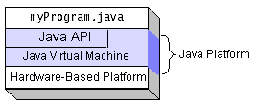

**Fig. 1**: Program running on Java platform

The Java platform consists of several programs, each of which provides a portion of its overall capabilities. For example, the Java compiler, which converts Java source code into Java bytecode (an intermediate language for the JVM), is provided as the part of the Java Development Kit(JDK). The Java Run Time Environment (JRE), complementing the JVM with a just-in-time (JIT) compiler, converts intermediate bytecode into native machine code on the fly. The extensive set of libraries is also part of the Java platform.

The essential component in the platform are the Java language compiler, the libraries, and the runtime environment in which Java intermediate bytecode ”executes” according to the rules laid out in the virtual machine specifications.

Java API and the virtual machine insulate the program from the hardware.

**3.3 JAVA VIRTUAL MACHINE**

The heart of the Java platform is the concept of a “virtual machine” that executes Java bytecode programs. This bytecode is the same no matter what hardware or operating system the program is running under. There is a JIT (just-in-time) compiler within the Java Virtual Machine (JVM). The JIT compiler translates the Java bytecode into native processor instruction at run-time and caches the native code in memory during execution. The use of bytecode as an intermediate language permits Java program to run on any platform that has a virtual machine available. The use of a JIT compiler means that Java application, after a short delay during loading and once they have “warned up” by being all or mostly JIT-compiled, tend to run about as fast as native programs. Since JRE version 1.2, Sun’s JVM implemented has included a just-in-time compiler instead of an interpreter. Although Java programs are cross-platform or platform independent, the code of the Java Virtual Machine (JVM) that executes these program is not. Every supported operating platform has its own JVM.

**3.4 CLASS LIBRARIES**

In most modern operating system (OSs), a large body of reusable code is provided to simplify the programmer’s job. This code is typically provided as set of dynamically loadable libraries that applications can call at run-time. Because the Java platform is not dependent on any specific operating system, applications cannot rely on any of the pre-existing OS libraries. Instead, the Java platform provides a comprehensive set of its own standard class libraries containing much of the same reusable functions commonly found in modern operating systems. Most of the system library is also written in Java. For instance, Swing library paints the user interface and handles even similar components.

The Java class libraries serve three purposes within the Java platform. First, like other standard code libraries, the Java libraries provide the programmer a well-known set of functions to perform common tasks, such as maintaining lists of items or performing complex string parsing. Second, the class libraries provides an abstract interface to tasks that would normally depend heavily on the hardware and operating system. Tasks such as network access and file access are often heavily intertwined with the distinctive implementations of each platform. The java.net and java.io libraries implement an abstraction layer in native OS code, then provide a standard interface for the Java applications to perform those tasks.

**3.5 LANGUAGES**

The word Java, alone, usually refers to the Java programming language that was designed for use with the Java platform. Programming languages are typically outside of the scope of the phrase “platform”, although the Java programming language is listed as a core part of the Java platform. The language and runtime are therefore commonly considered a single unit.

Nevertheless, third parties have produced many compilers or interpreters that target the JVM. Some of these are for existing languages, while others are for extensions to the Java language. These include:

* BeanShell- a light weight scripting language for Java.
* Clojure
* Groovy
* JRuby, a Ruby interpreter
* Jython, a Python interpreter that includes jythone, a Python-to-Java bytecode compiler
* Rhino, a JavaScript interpreter
* Scala
* Gosu

**3.6 JAVA DEVELOPMENT KIT**

The Java Development Kit (JDK) is a Sun product aimed at Java developers. Since the introduction of Java, it has been by far the most widely used Java software development kit (SDK). It contains a Java compiler, a full copy of the Java Runtime Environment (JRE), and many other important development tools.

**3.7 WHAT CAN JAVA TECHNOLOGY DO??**

The most common types of programs written in the Java programming language are applets and applications. An **applet** is a program that adheres to certain conventions that allow it to run within a Java-enabled browser.

An application is a standalone program that runs directly on the Java platform. A special kind of application known as a server serves and supports clients on a network. Examples of servers are Web servers, proxy servers, mail servers, and print servers. Another specialized program is a servlet. A servlet can almost be thought of as an applet that runs on the server side. Java Servlets are a popular choice for building interactive web applications, replacing the use of CGI scripts. Servlets are similar to applets in that they are runtime extensions of applications. Instead of working in browsers, though, servlets run within Java Web servers, configuring or tailoring the server.

**3.8 FEATURES OF JAVA PLATFORM**

Every full implementation of the Java platform gives you the following features:

* **The Essentials**: Objects, strings, threads, numbers, input and output, data structures, system properties, date and time, and so on.
* **Applets**: The set of conventions used by applets.
* **Networking**: URLs, TCP (Transmission Control Protocol), UDP (User Data gram Protocol) sockets, and IP (Internet Protocol) addresses.
* **Internationalization**: Help for writing programs that can be localized for users worldwide. Programs can automatically adapt to specific locales and be displayed in the appropriate language.
* **Security**: Both low level and high level, including electronic signatures, public and private key management, access control, and certificates.
* **Software Components**: Known as JavaBeans, can plug into existing component architectures.
* **Object Serialization**: Allows lightweight persistence and communication via Remote Method Invocation (RMI).
* **Java Database Connectivity (JDBC)**: Provides uniform access to a wide range of relational databases.

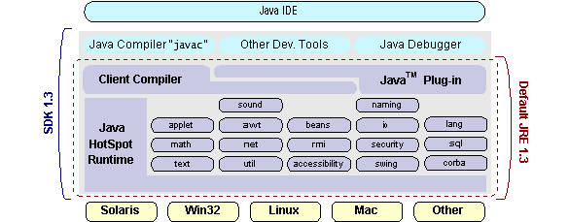

**Fig 2 Java 2 SDK**

The Java platform also has APIs for 2D and 3D graphics, accessibility, servers, collaboration, telephony, speech, animation, and more. The following figure depicts what is included in the Java 2 SDK.

**Java Program**

**Compilers**

**Interpreter**

**My Program**

**Fig 3 Working of Java program**

Each Java program is both compiled and interpreted. With a compile you translate Java program into an intermediate language called Java byte codes the platform independent code instruction is passed and run on the computer.

Compilation happens just once; interpretation occurs each time the program is executed. The figure illustrates how this works.

You can think of Java byte codes as the machine code instructions for the Java Virtual Machine (Java VM). Every Java interpreter, whether it’s a Java development tool or a Web browser that can run Java applets, is an implementation of the Java VM. The Java VM can also be implemented in hardware.

Java byte codes help make “write once, run anywhere” possible. You can compile your Java program into byte codes on my platform that has a Java compiler. The byte codes can then be run any implementation of the Java VM.

**4. SOFTWARES USED IN OUR PROJECT**

**4.1 NetBeans**

NetBeans is an integrated development environment (IDE) for developing primarily with Java, but also with other languages, in particular PHP, C/C++, and HTML5. It is also an application platform framework for Java desktop applications and others.

The NetBeans IDE is written in Java and can run on Windows, OS X, Linux, Solaris and other platforms supporting a compatible JVM.

The NetBeans Platform allows applications to be developed from a set of modular software components called *modules*. Applications based on the NetBeans Platform (including the NetBeans IDE itself) can be extended by third party developers.

**History:**

NetBeans began in 1996 as Xelfi (word play on *Delphi*), a Java IDE student project under the guidance of the Faculty of Mathematics and Physics at Charles University in Prague. In 1997 Roman Staněk formed a company around the project and produced commercial versions of the NetBeans IDE until it was bought bySun Microsystems in 1999. Sun open-sourced the NetBeans IDE in June of the following year. Since then, the NetBeans community has continued to grow.In 2010, Sun (and thus NetBeans) was acquired by Oracle.

**Platform:**

It is a framework for simplifying the development of Java Swing desktop applications. The NetBeans IDE bundle for Java SE contains what is needed to start developing NetBeans plugins and NetBeans Platform based applications; no additional SDK is required.

Applications can install modules dynamically. Any application can include the Update Center module to allow users of the application to download digitally signed upgrades and new features directly into the running application. Reinstalling an upgrade or a new release does not force users to download the entire application again.

The platform offers reusable services common to desktop applications, allowing developers to focus on the logic specific to their application. Among the features of the platform are:

* User interface management (e.g. menus and toolbars)
* User settings management
* Storage management (saving and loading any kind of data)
* Window management
* Wizard framework (supports step-by-step dialogs)
* NetBeans Visual Library
* Integrated development tools

NetBeans IDE is a free, open-source, cross-platform IDE with built-in-support for Java Programming Language.

**NetBeans IDE**

NetBeans IDE is an open-source integrated development environment. NetBeans IDE supports development of all Java application types (Java SE(including JavaFX), Java ME, web, EJB and mobile applications) out of the box. Among other features are an Ant-based project system, Maven support,refactorings, version control (supporting CVS, Subversion, Mercurial and Clearcase).

Modularity: All the functions of the IDE are provided by modules. Each module provides a well defined function, such as support for the Java language, editing, or support for the CVS versioning system, and SVN. NetBeans contains all the modules needed for Java development in a single download, allowing the user to start working immediately. Modules also allow NetBeans to be extended. New features, such as support for other programming languages, can be added by installing additional modules. For instance, Sun Studio, Sun Java Studio Enterprise, and Sun Java Studio Creator from Sun Microsystems are all based on the NetBeans IDE.

License: From July 2006 through 2007, NetBeans IDE was licensed under Sun's Common Development and Distribution License (CDDL), a license based on the Mozilla Public License (MPL). In October 2007, Sun announced that NetBeans would henceforth be offered under a dual license of the CDDL and the GPL version 2 licenses, with the GPL linking exception for GNU Classpath.

**4.2 MySQL:**

### MySQL, the most popular Open Source SQL database management system, is developed, distributed, and supported by MySQL AB. MySQL AB is a commercial company, founded by the MySQL developers. It is a second generation Open Source company that unites Open Source values and methodology with a successful business model .

The MySQL Web site (http://www.mysql.com/) provides the latest information about MySQL software and MySQL LAB.

* MySQL is a database management system.
* A database is a structured collection of data. It may be anything from a simple shopping list to a picture gallery or the vast amounts of information in a corporate network. To add, access, and process data stored in a computer database, you need a database management system such as MySQL Server. Since computers are very good at handling large amounts of data, database management systems play a central role in computing, as standalone utilities, or as parts of other applications.
* MySQL is a relational database management system.
* A relational database stores data in separate tables rather than putting all the data in one big storeroom. This adds speed and flexibility. The SQL part of “MySQL” stands for “Structured Query Language.” SQL is the most common standardized language used to access databases and is defined by the ANSI/ISO SQL Standard. The SQL standard has been evolving since 1986 and several versions exist. In this manual, “SQL-92” refers to the standard released in 1992, “SQL:1999” refers to the standard released in 1999, and “SQL:2003” refers to the current version of the standard. We use the phrase “the SQL standard” to mean the current version of the SQL Standard at any time.
* MySQL software is Open Source.
* Open Source means that it is possible for anyone to use and modify the software. Anybody can download the MySQL software from the Internet and use it without paying anything. If you wish, you may study the source code and change it to suit your needs. The MySQL software uses the GPL (GNU General Public License), http://www.fsf.org/licenses/, to define what you may and may not do with the software in different situations. If you feel uncomfortable with the GPL or need to embed MySQL code into a commercial application, you can buy a commercially licensed version from us. See the MySQL Licensing Overview for more information (http://www.mysql.com/company/legal/licensing/).
* The MySQL Database Server is very fast, reliable, and easy to use.
* If that is what you are looking for, you should give it a try. MySQL Server also has a practical set of features developed in close cooperation with our users. You can find a performance comparison of MySQL Server with other database managers on our benchmark page.
* MySQL Server was originally developed to handle large databases much faster than existing solutions and has been successfully used in highly demanding production environments for several years. Although under constant development, MySQL Server today offers a rich and useful set of functions. Its connectivity, speed, and security make MySQL Server highly suited for accessing databases on the Internet.
* MySQL Server works in client/server or embedded systems.
* The MySQL Database Software is a client/server system that consists of a multi-threaded SQL server that supports different backends, several different client programs and libraries, administrative tools, and a wide range of application programming interfaces (APIs).
* We also provide MySQL Server as an embedded multi-threaded library that you can link into your application to get a smaller, faster, easier-to-manage standalone product.
* A large amount of contributed MySQL software is available.
* It is very likely that your favorite application or language supports the MySQL Database Server.

The official way to pronounce “MySQL” is “My Ess Que Ell” (not “my sequel”).

### 

### 4.2.1 Features of MySQL

This section describes some of the important characteristics of the MySQL Database Software.

* Written in C and C++.
* Tested with a broad range of different compilers.
* Works on many different platforms.
* The MySQL Server design is multi-layered with independent modules.
* Fully multi-threaded using kernel threads. It can easily use multiple CPUs if they are available.
* Provides transactional and non-transactional storage engines.
* Uses very fast B-tree disk tables (MyISAM) with index compression.
* Relatively easy to add other storage engines. This is useful if you want to provide an SQL interface for an in-house database.
* A very fast thread-based memory allocation system.
* Very fast joins using an optimized one-sweep multi-join.
* In-memory hash tables, which are used as temporary tables.
* SQL functions are implemented using a highly optimized class library and should be as fast as possible. Usually there is no memory allocation at all after query initialization.
* The MySQL code is tested with Purify (a commercial memory leakage detector) as well as with Valgrind, a GPL tool (http://developer.kde.org/~sewardj/).
* The server is available as a separate program for use in a client/server networked environment. It is also available as a library that can be embedded (linked) into standalone applications. Such applications can be used in isolation or in environments where no network is available.

**4.3 SQLyog**

**SQLyog** is a GUI tool for the RDBMS MySQL. It is developed by Webyog, Inc. based out of Bangalore, India and Santa Clara, California.

**Features**

Prominent features of SQLyog are:

* 64 bit binaries are available from version 11.0.
* Tabbed interface for connections. Connections can be given a colour for identification.
* Editor with syntax highlighting and various automatic formatting options.
* Intelligent Code Completion.
* Data manipulations (INSERT, UPDATE, DELETE) may be done from a spreadsheet-like interface. Both raw table data and a result set from a query can be manipulated.
* Rich context menus etc. for performing common tasks without writing SQL.
* Visual Schema Designer.
* Visual Query Builder.
* Query Formatter.
* Connectivity options: Direct client/server using MySQL API (SSL supported), HTTP/HTTPs Tunnelling, SSH Tunnelling.
* Wizard driven Tool for import of data from ODBC-databases
* Backup Tool for performing unattended backups. Backups may be compressed and optionally stored as a file-per-table as well as identified with a timestamp.
* 'SQL Scheduler and Reporting Tool' - a tool for scheduling and automating execution of any sequence of SQL statements. Result of queries may be sent as HTML-formatted reports.
* Schema/Structure Synchronization and Data Synchronization.
* Query Profiler and Redundant Index Finder.
* All automated jobs have mail alerting and reporting options.
* Full character set/Unicode support.
* Optionally portable. All files used by SQLyog may be saved to a removable drive etc.
* A 'Data Search' feature using a Google-type search syntax translated transparently for user to SQL.
* Form view to display one row at a time - a great way to enter/edit data.
* Foreign key lookup.

**5. SYSTEM DESIGN**

System design is the solution to the creation of a new system. This phase is composed of several systems and focuses on the detailed implementation of the feasible system. System design has two phases of development logical design and physical design

**5.1 HARDWARE REQUIREMENTS**

Hardware is the term given to machinery itself and to various individual pieces of equipment. It refers to the physical devices of a computer system. Thus the input, storage, processing control and output devices are hardware.

**Minimum Hardware Requirement :**

* **Processor** : 2.6 GHz Intel Pentium IV or Equivalent
* **Memory**  : 512 MB RAM (Recommended 2GB RAM)
* **Disk Space** : 1 GB of free disk space
* 15 inches Color Monitor
* 104 Keys Keyboard

**5.2 SOFTWARE REQUIREMENTS**

Software means a collection of program where the objective is to enhance the capabilities of the hardware machine.

**Minimum Software Requirement**

**Operating System:** Windows 2000/XP or above

* MySQL
* SQLyog
* JDK
* NetBeans IDE

**6. UML DIAGRAMS**

**6.1 USE – CASE DIAGRAM**

* LEAVE

**Fig. 4**: Use - Case For Detection Of Mobile Cloning

**USE CASE DESCRIPTION**

|  |  |  |  |  |  |  |  |  |
| --- | --- | --- | --- | --- | --- | --- | --- | --- |
| **S.NO** | **USE CASE** | **USE CASE DESCRIPTION** | **ACTORS** | **BASIC FLOW** | **ALTERNATE FLOW** | **PRE CONDITION** | **POST CONDITION** | **RELATED USE CASES** |
| 1. | LOGIN | Describes how the user registers into the system | Client and Server. | Client registers into the database by entering name, address, password and a valid phone no. | If the client do not register properly the client will not be registered into the database. | Client must have a valid mobile no and a valid all the other data. | Clients are registered in the system and its all information is stored into the database. | - |
|  | | | | | | | | |
| 2. | REGISTER  THE AUTHORISED  USER | Allows the server to save the client information into the database. | Server | Client will be registered in the database by clicking the register button or cancel the registration by clicking on the cancel button. | If the client registers the same number which already exist in the database then it will not be registered and a message prompts. | Client should not be using the duplicate number to register into the database. | Client will be registered successfully and its all information will be saved in the database. | - |
|  | | | | | | | | |
| 3. | UNAUTHORISED USER REGISTRATION FAILED | Allows the server to detect the duplicate number hence it is not registered | Client | Server will check for the duplicate number and hence it will block its registration. | If the number is found to be complete different then server will automatically register the number. | To show cloning the number entered should be a duplicate one only | Fake user will not be registered and its account will be blocked. | - |
|  | | | | | | | | |
| 4. | BLOCK THE ACCOUNT OF THE FAKE USER | It will block the unauthorised user and a message is prompted | Server | The server will completely block the fake user. | If the number is found to be complete different then server will automatically register it | Number should be already registered in the database. | A message prompts which shows the presence of unauthorised user. | - |
|  | | | | | | | | |
| 5. | SHOW CLONING | To actually detect cloning how it take place . | Server | The Server will check for the cloned number when it is clicked the database is opened which shows all the number registered. | To check for the cloning this button only shows the database and if the user is not registered we can not show cloning. | User must be registered first to show cloning. | If the client is registered then we can check for the cloning by clicking on the phone and clone button. | - |
|  | | | | | | | | |
| 6. | DATABASE SHOWING USER REGISTRATION | It allow to maintain the whole database of the client registered to the system | Client | when the user is registered we can see it in the database. It will maintain the whole information of the user. | If the number already exists in the database then it will not be saved in it again. | User must be successfully registered | If the user is not present in the database then the user with same number can be registered again. | - |
|  | | | | | | | | |
| 7. | PHONE SHOWS ACTUAL LOCATION | It is used to detect the location of registered user. | Client and Server | The server will detect the actual location of the authorised user. | If the user is not selected it will not check for the location of user | User must be registered and it must be selected. | If the phone button is clicked we should note for the location of the number. | - |
|  | | | | | | | | |
| 8. | CLONE BUTTON SHOWS CLONING | It is used to show cloning of the button | Client and Server. | The Server will detect the clone phone and its account will be blocked . | If the clone button shows the same location then it should not show the cloning . | Cloned phone should have the same number and different location. | If the location is different the user will not be registered and its account will be blocked. | - |
|  | | | | | | | | |

**Table 1**: Use Case Descriptions

**6.2 WORKFLOW DIAGRAM**

REGISTRATION PANEL

**WRONG USERNAME OR PASSWORD**

**LOGIN SUCCESSFULL**

REGISTER

**INVALID USER**

**VALID USER**

SELECT OPTION

REGISTER

CANCEL

SHOW CLONING

**Fig. 5**: Workflow For User Registration

SHOW CLONING

**WRONG USERNAME OR PASSWORD**

**LOGIN SUCCESSFULL**

CHECK FOR REGISTERED USER

**INVALID USER**

**VALID USER**

SELECT ANYUSER

CLONE BUTTON

PHONE BUTTON

Shows the same mobile number and its different location

Shows the registered mobile number and its location

**Fig. 6**: Workflow for Cloned Phone

**6.3 SEQUENCE DIAGRAM**

Registration

System

Registration Panel

Admin Panel

Administrator

1. Username/password

2. Authentication succeed

3. Request Registration

4. Registration Form

5. Fill Details

6. Register

7. Show Registration Status

Cloning Detection

Illegal User

Database

Cloning panel

1. Selection of Phone to Clone

2. Fetch detail of targeted Phone

3. Start Cloning

4. Show mobile no. and location

5. Display status

**Fig. 7**: Sequence Diagram

**6.4 E-R DIAGRAM**

Legal User Details

Registers

Administrator

Phone

Uses

**Fig. 8**: Entity Relationship Diagram

**6.5 DATA FLOW DIAGRAM**

Client details Client Details

SERVER

CLIENT

Client registered Client registered

If legitimate if it is legitimate

otherwise blocked.

**Level - 0 DFD**

**Fig. 9**: Level-0 DFD

Cloned number and account blocked

Checks for cloning

Client details client details

CLIENT

SERVER

Client registered Client registered if

If it is legitimate it is legitimate.

Checks for cloning

Cloned number and account blocked

**Level - 1 DFD**

**Fig. 10**: Level-1 DFD

**7. TESTING**

|  |  |  |  |  |  |  |  |  |
| --- | --- | --- | --- | --- | --- | --- | --- | --- |
| **S.No**. | **DESCRIPTION** | **PRE CONDITION** | **INPUT** | **EXPECTED OUTPUT** | **ACTUAL OUTPUT** | **POST CONDITION** | **TEST PASS/ FAIL** | **REMARK** |
| 1. | Users Log in Functionality | Must have a name, pswd, email, address, and a valid mobile number | Name, pswd, email, address, and a mobile number | If the details are valid the users are registered in database. | Data are registered successfully. | If the user with the same mobile number will not be there then only it will be registered. | Pass | - |
| 2. | Users Log in Functionality | Must have a name, pswd, email, address, and a same mobile number already registered. | Name, pswd, email, address, and a same mobile number | If the number is same then the user will not be registered. | Users with same number have not been registered and a message prompt occurs that the user can not be registered | To check this functionality the user should enter the same mobile number. | Pass | - |
| 3. | To show actual location of registered user | User must have been registered before it should not be empty. | Select the Mobile number to which you want to know location and click on the phone button. | It should show the registered mobile number and its present location. | A pop window opens and it shows the number and its actual location of the mobile number. | Person should select any mobile number before clicking on the phone button to find its location | Pass | - |
| 4. | To show cloned phone. | User must have been registered before it should not be empty. | Select the Mobile number to which you want to show cloning and click on the clone button. | It should show the cloned mobile number and its account should be blocked | A pop window opens and it shows the same number with different location and hence its account is blocked. | To show cloning person should select the same number . | Pass | - |

**Table 2**: Test Cases

**8. CONCLUSION**

It has been a great pleasure for us to work on this exciting and challenging project. This project proved good for us as it provided practical knowledge of not only programming in Java and MySQL Server, but also about the processes related to mobile communication and ‘Mobile Cloning’**.** We learned about how menacing this practice of Mobile Cloning proves for our society and the country as a whole.We were also endowed with the knowledge about the latest technology used in mobile computing and client - server technology that will be great demand in future. This will provide better opportunities and guidance in future in developing projects independently.

**BENEFITS:**

The project is identified by the merits of the system offered to the user. The merits of this project are as follows: -

* This project enables the user to virtually detect Mobile Cloning through a Client-Server system using a combination of two techniques, i.e. Duplicate Detection and Velocity Trap.
* This project offers user to enter the data through simple and interactive forms. This is very helpful for the client to enter the desired information through so much simplicity.
* Data storage and retrieval will become faster and easier to maintain because data is stored in a systematic manner and in a single database.

**LIMITATIONS:**

* The size of the database increases day-by-day, increasing the load on the database back up and data maintenance activity.
* This project although is competent enough to detect Mobile Cloning, but it does not provide any means to prevent or curb it.
* Training for simple computer operations is necessary for the users working on the system.

**9. APPENDIX**

**SCREENSHOTS**

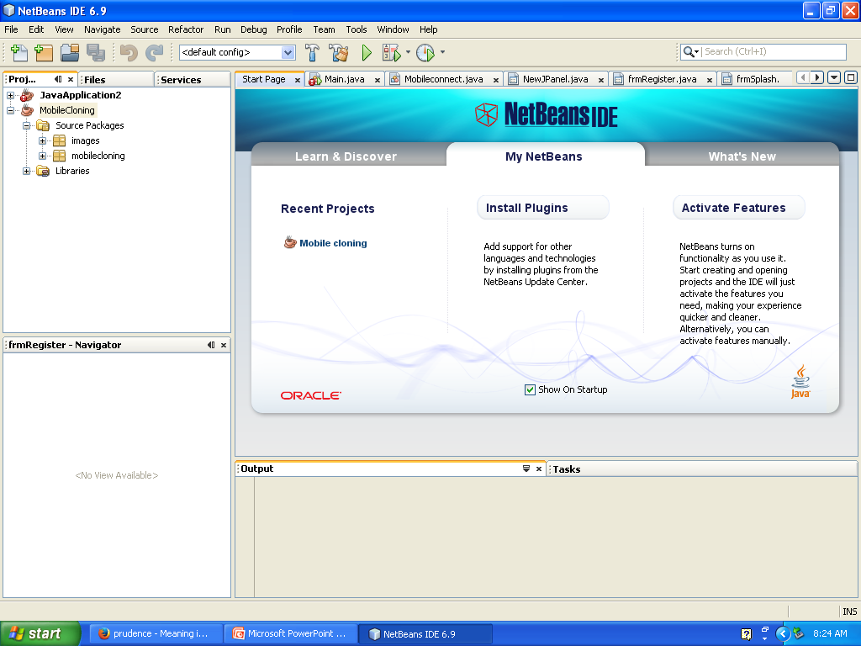

**Fig. 11**: Open the NetBeans IDE. Click on the project ‘Mobile Cloning’ and run the project.

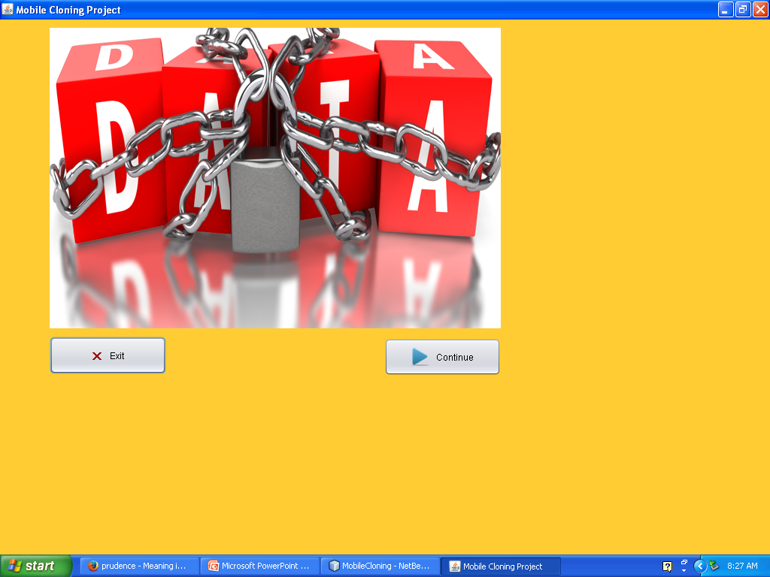

**Fig. 12**: After running the project you will get a pop up window. Click on continue

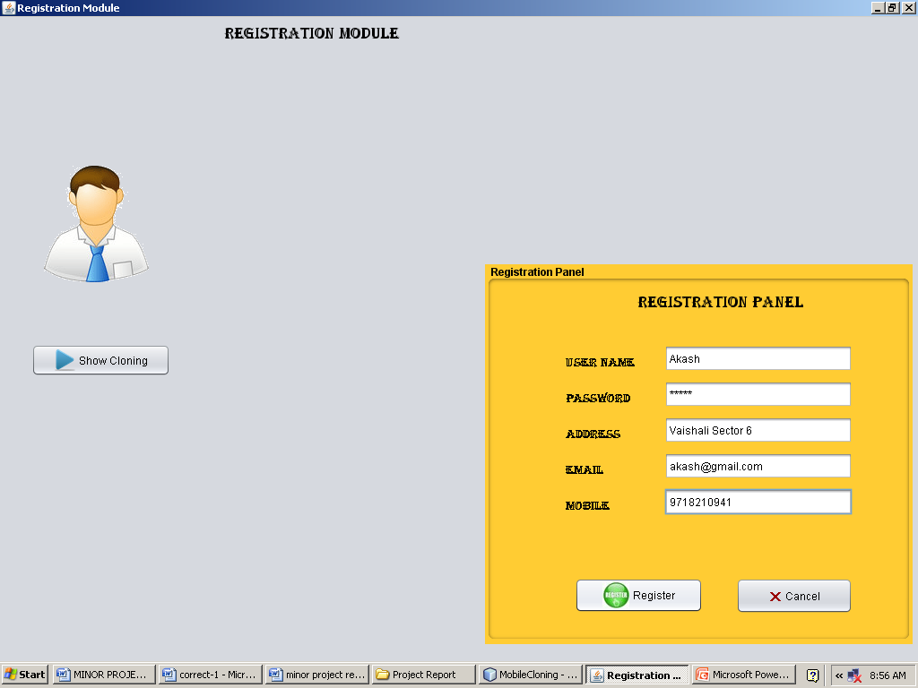

**Fig. 13**: After that you will get a registration window where you have to register yourself

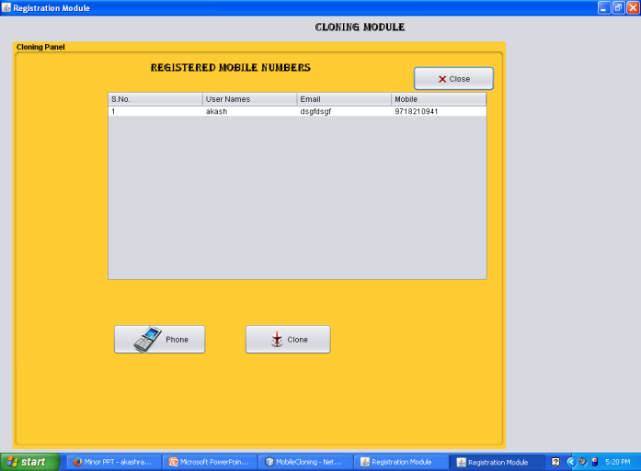

**Fig. 14**: When you click on the show cloning a window appears which contain all the data registered to it.

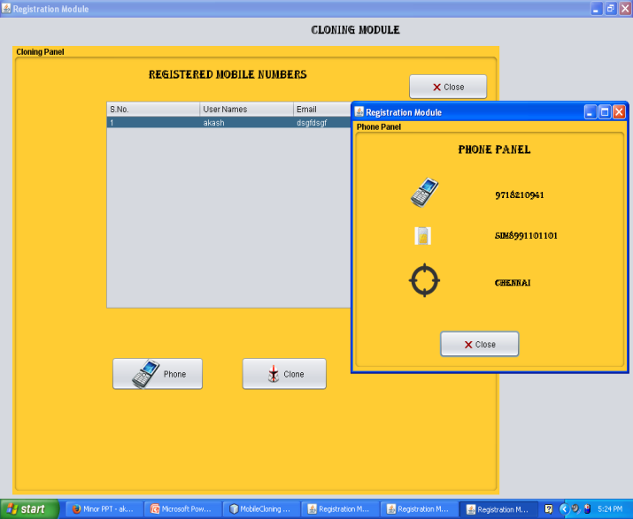

**Fig. 15**: After getting the register window select a contact to which you want to detect the cloning and click on the phone button which shows the details of the fair registered user and his/her location.

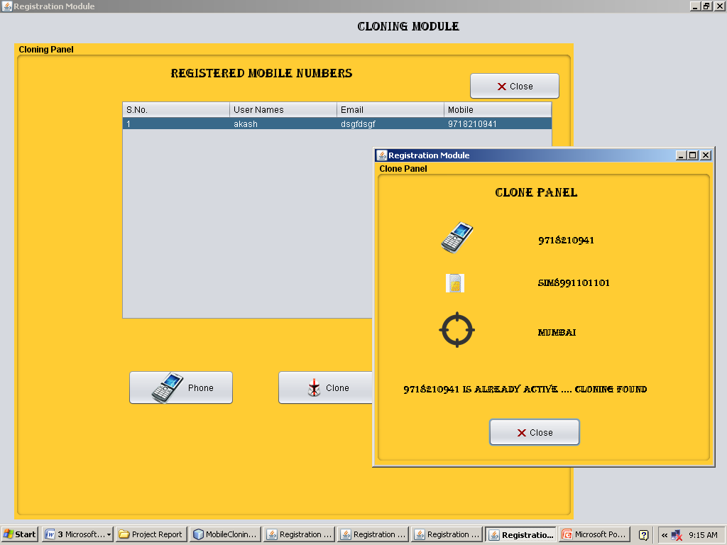

**Fig. 16**: This window shows the cloned phone.

**10. BIBLIOGRAPHY**

* 1. Trickdad - SIM Cloning Tutorial - <http://www.trickdad.com/2012/09/sim-cloning-tutorial.html>
  2. Security Tube - Cloning Simcards And Hacking Payphones - <http://www.securitytube.net/video/194>
  3. How To Clone Any SIM Card - <http://iyowun.wordpress.com/2009/07/04/how-to-clone-any-sim-card/>
  4. The Complete Reference – Java (7th Edition) – Herbert Schildt – Tata McGraw Hill
  5. Dream.In.Code – Creating A Server To Serve Clients - <http://www.dreamincode.net/forums/topic/38672-creating-a-server-to-serve-clients/>